POLYMORPHISM THROW INTERFACE IN GLOBAL CLASS
STEP:1 CREATE INTERFACE IN SE24
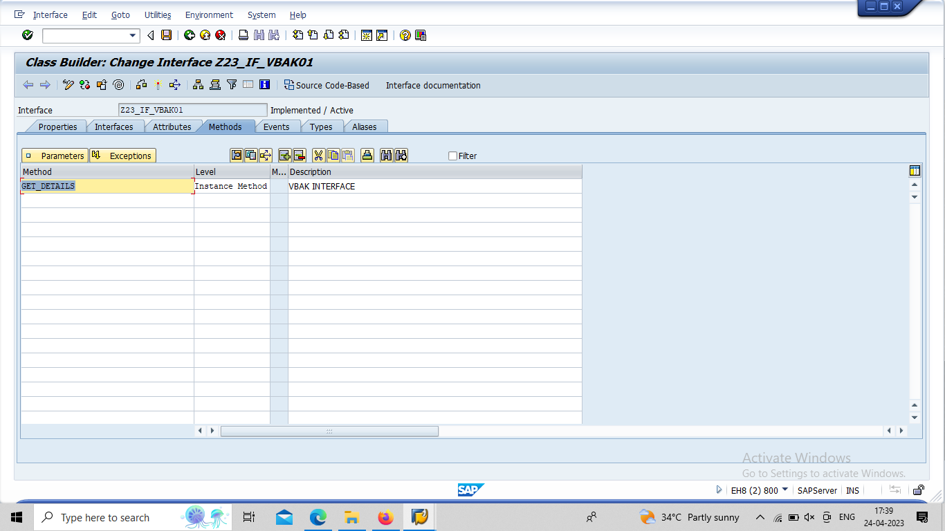

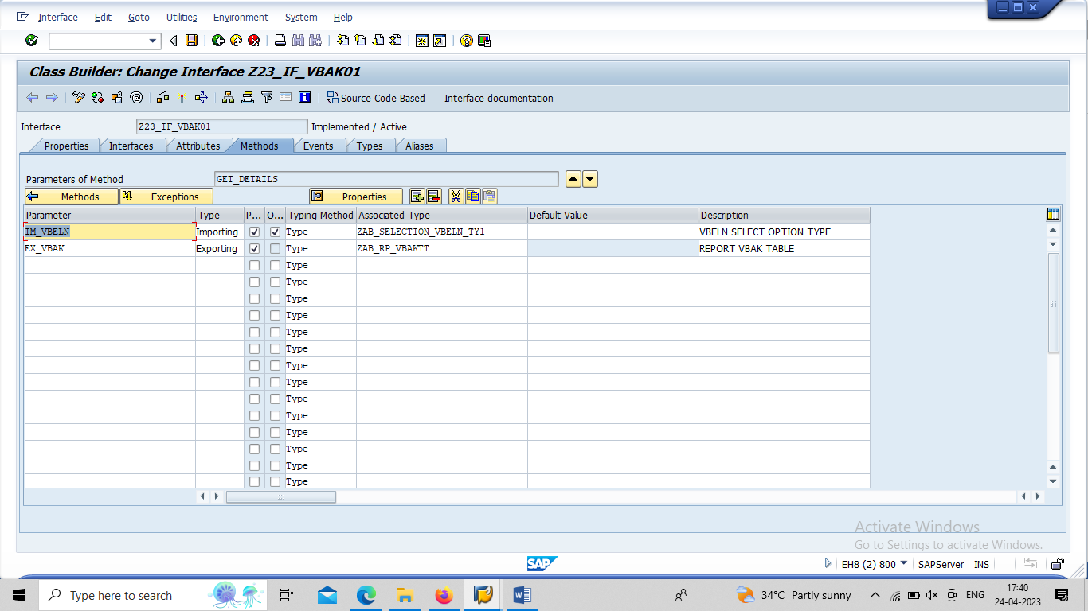

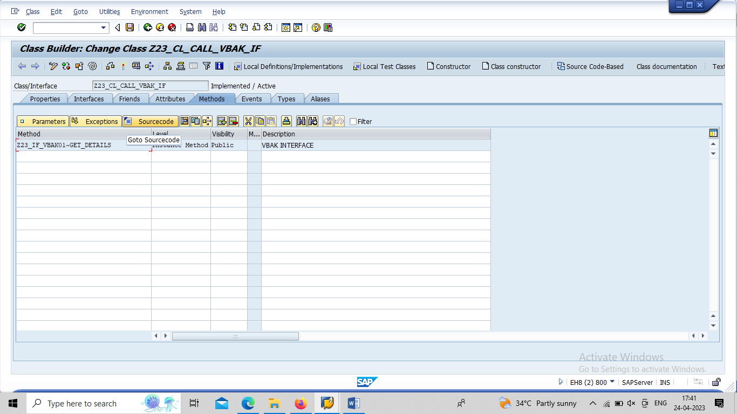

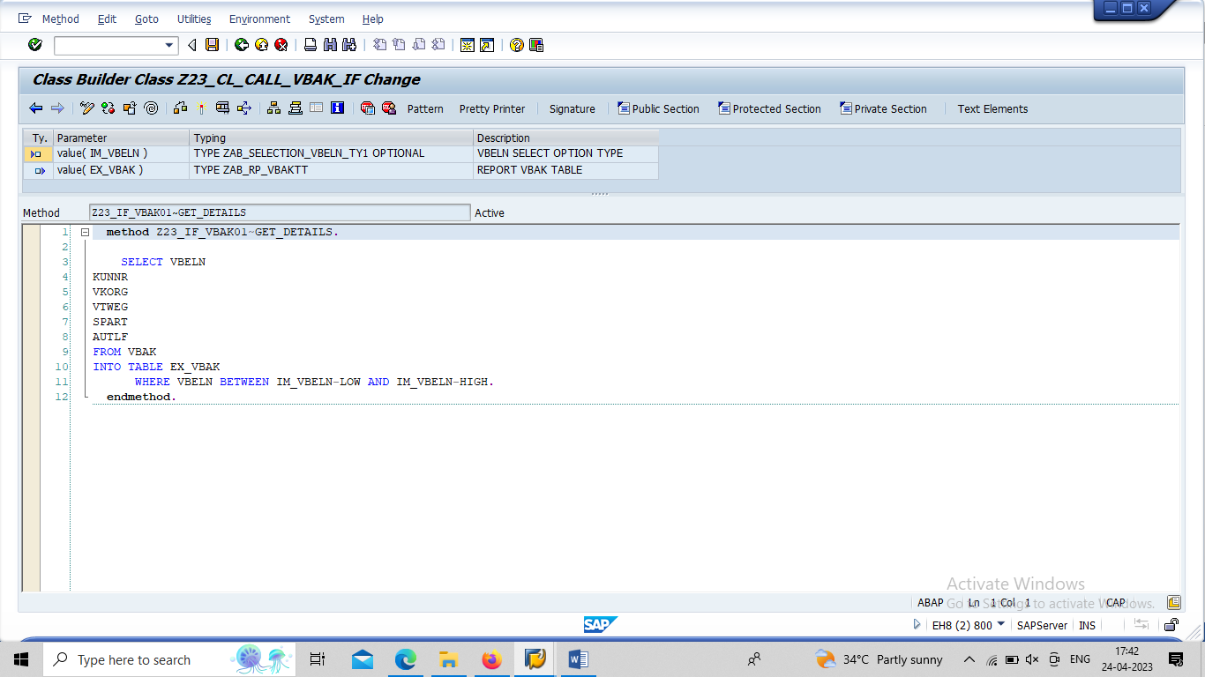

CALL SE38
REPORT ZTESTING_OOABAP_05_CALL_IF.
DATA:
IT_VBAK TYPE ZAB_RP_VBAKTT,
WA_VBAK TYPE ZAB_RP_VBAKSTR,
VBELN TYPE VBELN,
OBJ TYPE REF TO Z23_CL_CALL_VBAK_IF.
SELECT-OPTIONS S_VBELN FOR VBELN.
START-OF-SELECTION.
CREATE OBJECT OBJ.
CALL METHOD OBJ->Z23_IF_VBAK01~GET_DETAILS
EXPORTING
IM_VBELN = S_VBELN
IMPORTING
EX_VBAK = IT_VBAK.
LOOP AT IT_VBAK INTO WA_VBAK.
WRITE:/20 WA_VBAK-VBELN,
35 WA_VBAK-KUNNR,
55 WA_VBAK-VKORG,
67 WA_VBAK-VTWEG,
80 WA_VBAK-SPART,
96 WA_VBAK-AUTLF.
ENDLOOP.

